Apache Kafka

Works on Pub-Sub model help to exchange data between 2 senders

Sender -> Publish ->Apache Kafka -> Subscribe-> Receiver

Sender will publish to Apache Kafka and Receiver will subscribe to apache kafka such that receiver can get the message send by sender.

Examples of Kafka (where it is used)

1.OLA Driver location update

2.Zomato live food tracking

3.Notification system to huge user

All these problems are based on pub sub model and thus we use kafka as streaming service where a consumer is waiting for messages.

Advantage

1. High Throughput
2. Fault Tolerance(Replication)
3. Durable
4. Scalable
5. Reliable

Kafka Architecture

Components

1. Producer
2. Consumer

Kafka Ecosystem

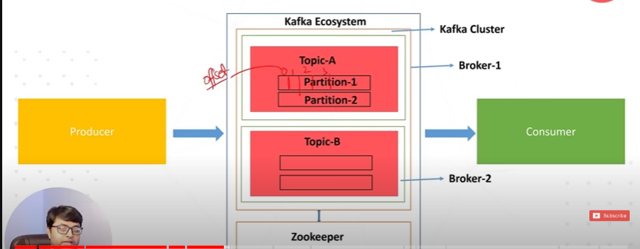

Kafka Cluster

different brokers which act as server which receive data and send data

brokers store data in topic(used to catergories the data) different topics are created based on data like user,accounts,transaction

Inside topics we store data in partitions which are used for replication and with the help of offset

connected with Zookeeper

Installation

Download kafka

extract file

Start zookeeper

cmd

bin/windows/zookeeper-start config/zookeeper properties

bin/windows/server-start config/serverproperties

Kafka With console

Create a new topic with kafka topics

bin\windows\kafka-topics.bat --create --topic user-topic --bootstrap-server localhost:9092

produce example message with kafka console producer

>bin\windows\kafka-console-producer.bat --topic user-topic --bootstrap-server localhost:9092

consume the message with kafka-console consumer

bin\windows\kafka-console-consumer.bat --topic location-update-topic --from-beginning --bootstrap-server localhost:9092